**PeaceTrack Mobile Application**

**Design Document**

Bhagya Hettige

12/06/2015

1. **Introduction**

PeaceTrack is a mobile application designed for the volunteers in Peace Corps to track their day-to-day volunteering tasks. The mobile aplication is developed in two versions, Android and iOS. Volunteers serve the world by giving hand to the people in rural communities to improve their knowledge, literacy and skills. Activities are performed on a specific community to achieve the expected positive outcomes. Then the volunteers performs tests necessary to measure the outcomes in the community. Peace Corps uses these measured outcome data to derive useful statistical information about the communities and activities. Data has to be recorded even in offline state, and synchronized with the central database when connected to a network.

The manual recording system of the volunteering tasks is a long, error-prone process. Currently the volunteers have to spend a tremendous amount of time filling the forms by hand and submitting. Then there should be a data entry operator to enter all the collected data in digital format in order to store in the central database.

This document intends to present the overall design of the system, users of the system, relationships among the entities and the database structure.

1. **Main entities associated with the application**
2. **Cohort**

A cohort is a group of people on which an activity is targeted at.

E.g.-: Study group of 50 students, football team, senior citizens

The central database should hold the cohort information globally to track cohort performances, to compare with other cohorts and to make decisions on improving future activities. Following are the data to be recorded in the central database about a particular cohort.

* Cohort identification number (unique across ALL the cohorts)
* Cohort name
* Post
* Sector
* Description
* Activities

In the mobile application we have to track these data. When a volunteer creates a new cohort, the following data have to be tracked and stored locally in the phone.

* Cohort name (unique across the cohorts reported by the volunteer)
* Description
* Activities

1. **Activity**

An activity is a task carried out by a volunteer for a cohort. Activities are associated with a number of outputs.

E.g.-: Football game organized to discuss and improve awareness of Malaria, workshop organized to teach English

With activities, Peace Corps can track the volunteer performance and activeness of cohorts. The data which have to be recorded in the central database are as follows.

* Activity identification number
* Activity title
* Location
* Description
* Cohort participated
* Date
* Time
* Outputs and data

The phone local storage should hold the following data. When the volunteer creates an activity, these data should be provided.

* Activity title
* Description
* Cohort
* Date
* Time
* Outputs and data

1. **Measurement**

A measurement is positive or negative effect of an activity on a cohort.

In a measurement, the important data to be stored in the central database are as follows.

* Measurement identification number
* Measurement title
* Date
* Time
* Cohort
* Outcome and data

When a volunteer tracks a measurement, the data to be recorded in the local phone storage are as follows.

* Measurement title
* Cohort
* Outcome and data

1. **Impact**

An impact is a graphical view of multiple measurements with a common outcome.

Information to be derived

* Represent the performance for a particular outcome of a cohort over time
* Compare performance for a particular outcome with different cohorts
* Compare a particular output of an activity with different cohorts (e.g.- attendance)

1. **Frontend Design**

Frontend design of an application heavily affects the usability of the application. We should consider several factors when designing the user interfaces for the users to interact with computing device – learnability, efficiency of use, error handling and acceptability.

We should decide on the user interface changes with the Peace Corps and finalize the design. UI wireframes should be designed as the next step to start implementation.

This section provides the main work-flow associated with the main operations in PeaceTrack mobile application.

**3.1. Login 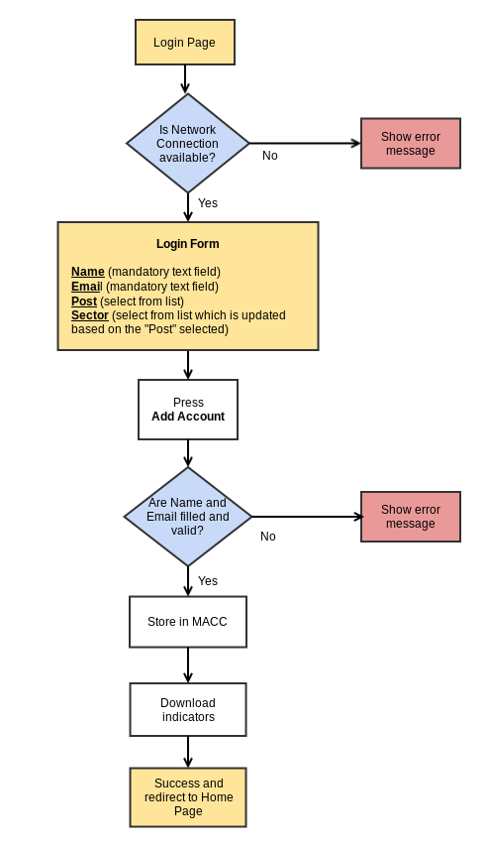Flow**

**3.2. Cohort Flow**

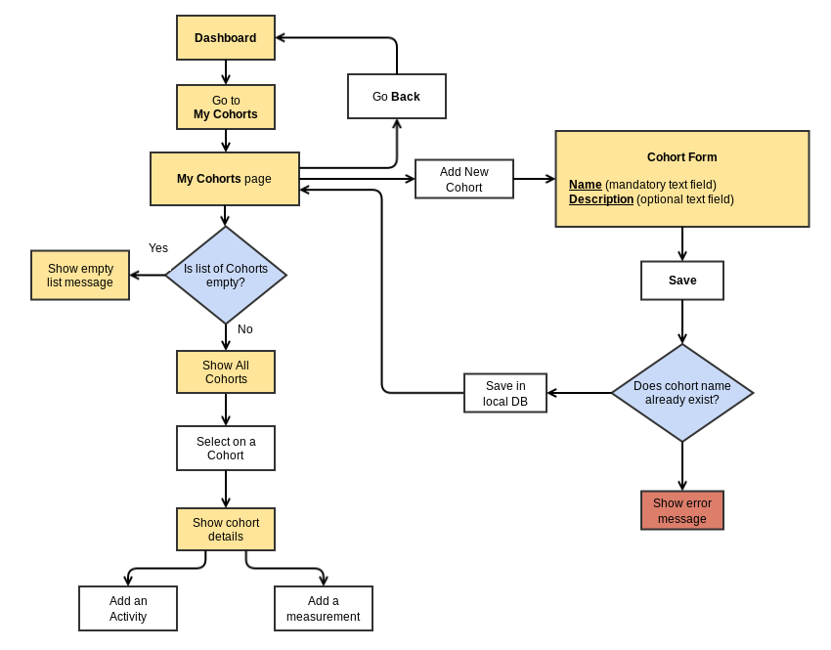

1. **Backend Design**

The data recorded by the volunteers should be sent to the central database via internet. But due to the network connection issues in the rural communities where the volunteers work, they cannot connect to the internet very often. As a solution to this problem, we expect to have the data entered in the local database and synchronize the data with the central server whenever the mobile device is connected to a network. Therefore we identified 2 main states of the application where data storage can be handled.

|  |  |
| --- | --- |
| **Offline state** | The data recorded are stored in the local database with a flag “isSynched” set to FALSE. |
| **Online state** | Manual synchronization or automatic synchronization can be enabled from the settings.  Send the data saved with the flag “isSynched” set to FALSE in the local database to the central database. |

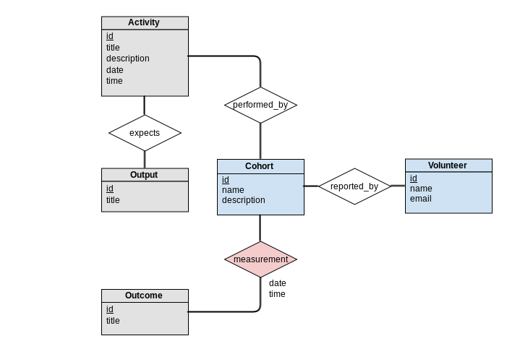**4.1. Database Design for Mobile Application**

**4.2. Database Design for MACC**

